fJob Title: | 2nd Line IT Support Technician | Location/Service: | Hesley Hall / Central Services
Department: | IT Services | Reports To: | Director of Data & IT
Responsible For: | N/A | Budgetary Responsibility: | N/A
Level of DBS Check Required: | Basic | Expected Regulatory Responsibility: | N/A
Does the role require travel to multiple sites? | Yes

Purpose:
The purpose of the role is to support the Director of Data & IT in delivering key technology initiatives, improving systems, and ensuring the stability and security of our IT environment.

This role bridges day-to-day operational support with strategic technology delivery, an ideal opportunity to step beyond traditional support and contribute directly to solution design, implementation, and continuous improvement across the business.

There will be focus on deploying new technologies, troubleshooting complex issues, and supporting the Director of Data & IT in driving innovation and security best practice across Microsoft 365 and related systems.
Key Role Responsibilities/Accountabilities:
Technology Delivery & Implementation
- Assist the Director of Data & IT with planning, testing, and rolling out new technologies, tools, and services
- Research and evaluate potential solutions aligned to business needs, preparing recommendations or pilots
- Take ownership of the technical delivery of projects, configuration, deployment and documentation
2nd / 3rd Line Technical Support
- Provide escalation support for complex technical incidents and problems liaising with the IT Service team as required
- Ensure issues are resolved efficiently and knowledge is shared with the IT Service team
Microsoft 365 Administration and Security
- Manage and optimise Microsoft 365 services including Exchange Online, Teams, SharePoint, Intune and Azure AD
- Implement and monitor security policies, identity management, MFA and conditional access
Continuous Improvement
- Identify opportunities to automate, streamline, and enhance IT operations
- Maintain strong awareness of emerging technologies and propose improvements
Collaboration and Governance
- Work closely with the Director of Data & IT on IT strategy execution, documentation, and compliance initiatives (e.g. Cyber Essentials Plus, ISO 27001)
- Maintain accurate configuration, process, and technical documentation
- Provide mentoring and technical guidance to IT Apprentices and 1st Line IT staff where appropriate

Legal and Statutory Responsibilities for all Colleagues:
Safeguarding: All colleagues have a duty to maintain a basic level of understanding of safeguarding, signs of
neglect or abuse and how to raise a safeguarding concern as outlined in the organisations Safeguarding and
Whistleblowing policies.

Health & Safety: All colleagues have a duty to take reasonable care for the health and safety of themselves and others. This includes contributing to a safe and secure environment for the people who use our services.
Training Compliance: All colleagues are responsible for maintaining compliance with all mandatory training required for the specific job role they undertake or service they work in, any required qualifications and maintaining any required professional registrations to ensure professional skills and knowledge remain up to date.

Information Governance: All colleagues have a duty to main the confidentiality and integrity of any sensitive or personal data that they access or use within their role.

Diversity and Inclusion: All colleagues are expected to contribute to the development of an inclusive workplace and treat others with dignity and respect at all times.

Line Management: Roles with line management responsibility are expected to ensure all direct reports, and teams they oversee, receive the appropriate levels of supervision and have an annual performance review and contribute to a culture of continuous improvement and development.

Person Specification:
Skills/Abilities
Essential
Proactive problem solver: anticipates issues and proposes solutions
- Curios and innovative: enjoys learning and experimenting with new technologies
- Analytical and structured: able to document, plan, and deliver projects methodically
- Strong communicator: can translate technical issues into clear, actionable information for non-technical colleagues
- Collaborative: works effectively with colleagues at all levels, including senior management
- Accountable: takes ownership of outcomes and follows through to resolution
- Security-minded: understands the importance of protecting information and systems.
Desirable
- Experience working in a regulated or compliance-focused environment
- Exposure to automation or integration tools (e.g. Power Automate, Logic Apps)

Technical Requirements
Essential
- Proven experience in a 2nd Line Support, Systems Engineer, or similar role
- Strong technical knowledge of:
- Microsoft 365 administration: Exchange Online, Teams, SharePoint, OneDrive, Intune and Azure AD
- Windows Server environments and Active Directory (on-prem and hybrid)
- Endpoint management: Intune / Autopilot / application deployment
- Security tools: Defender for Endpoint, conditional access, MFA, device compliance
- Networking fundamentals: DNS, DHCP, VPN, VLANs, firewalls
- Understanding of backup, DR, and business continuity principles

Desirable
- Experience with PowerShell scripting or automation tools
- Familiarity with Cyber Essentials Plus and / or ISO 27001 standards

Qualifications and Experience
Essential
- Demonstrable experience in IT support or systems administration
- Experience supporting technology transformation or project delivery initiatives
- Demonstrable ability to manage and deliver small to mid-scale IT projects
Desirable
- Microsoft 365 or Azure certifications

Our Values and Key Attributes:
All colleagues are expected to operate in line with our Values and Behaviour Framework at all times. The framework outlines our core values and the behaviours that we consider to uphold each of our values, as well as universal attributes we consider to underpin everything we do.

Our Values
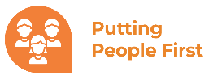
We put the people we support, families and colleagues at the centre of all we do.
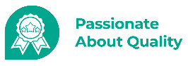
We recognise that quality comes from our commitment to best practice, improvement and learning; not just compliance.
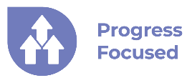
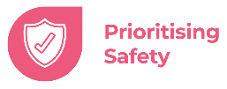
We are passionate about improving lives and work together to enable the people we support to achieve their aspirations.
We embrace a culture of trust and safety so that each of us can perform to our best and thrive.

Universal Attributes
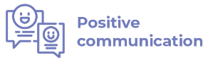
Communication is a two-way street; as well as honesty, we actively listen so we can
understand the needs and views of others.
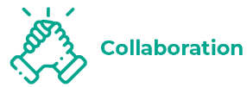
Good collaboration between individuals strengthens the team as a whole, enabling
us to share ideas, encouraging others to adopt new skills, while learning from others
ourselves.
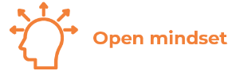
By taking a non-judgmental approach, we can demonstrate empathy and be seen
as approachable, while respecting the culture and opinions of our peers.
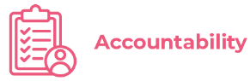
We are accountable for our own actions, and by sharing the lessons we learn in our
working lives, we do things better individually and more broadly as an organisation.

Last Updated By: | Director of Data & IT | Date: | 23/04/2026

